# **1Project Deliverable 2 -**

**Group 11**

1. Rishi Vamshi Athinarap
2. Venkata Sai Shalini Ganni
3. Siva Naga Rutwik Reddy Chintha
4. Darshini Chalumuri

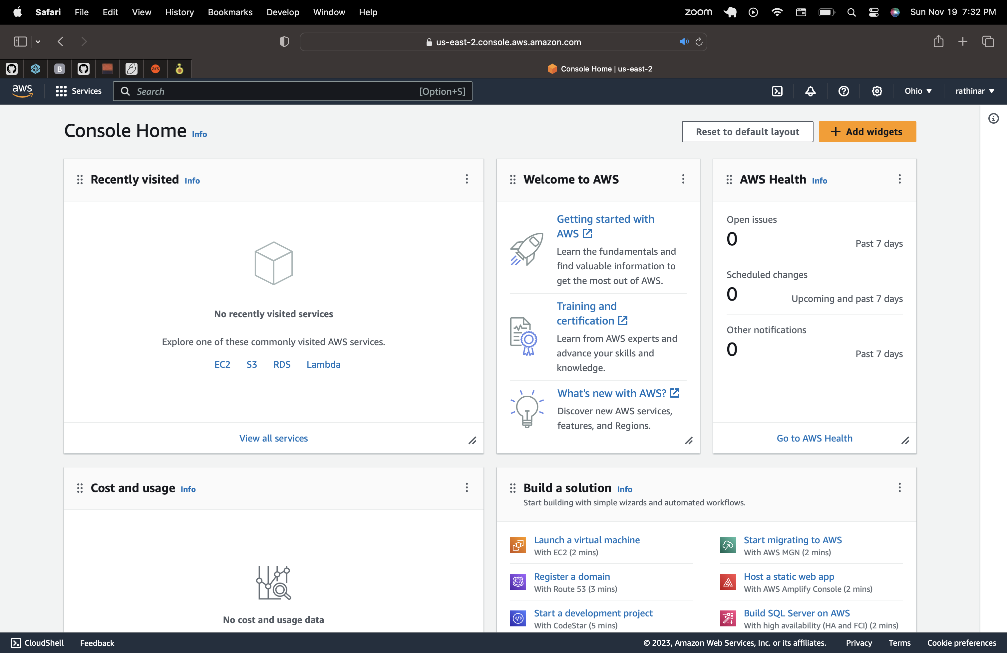

**IAM user setup for team -**

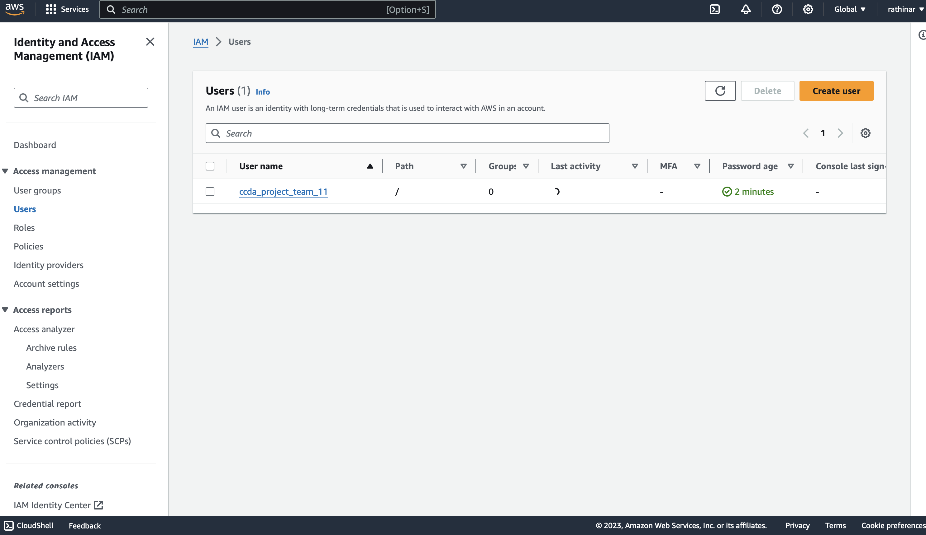

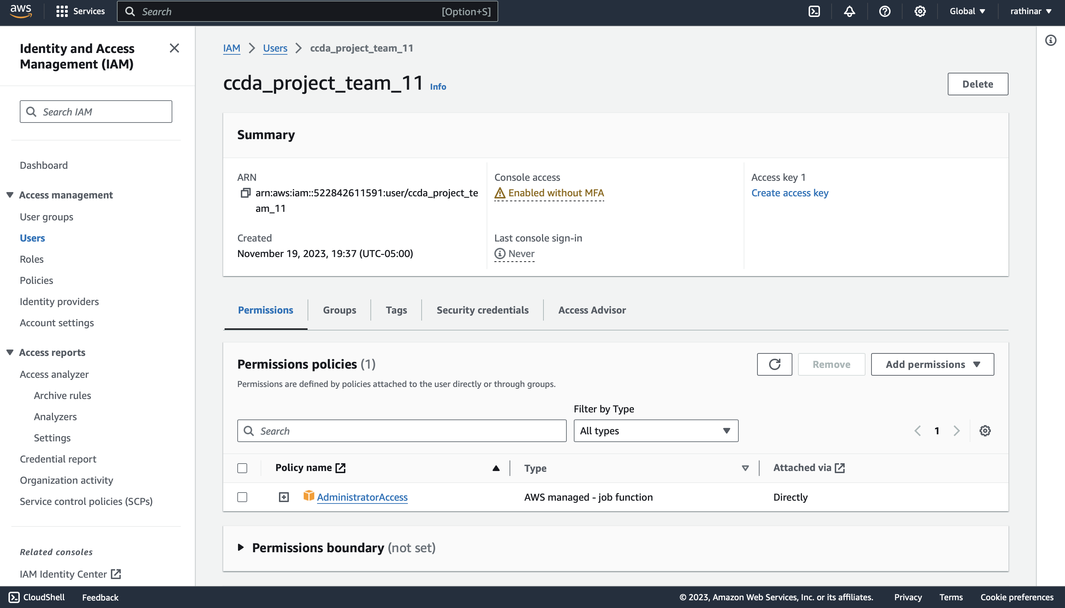

**Logged into user – ccda_project_team_11**

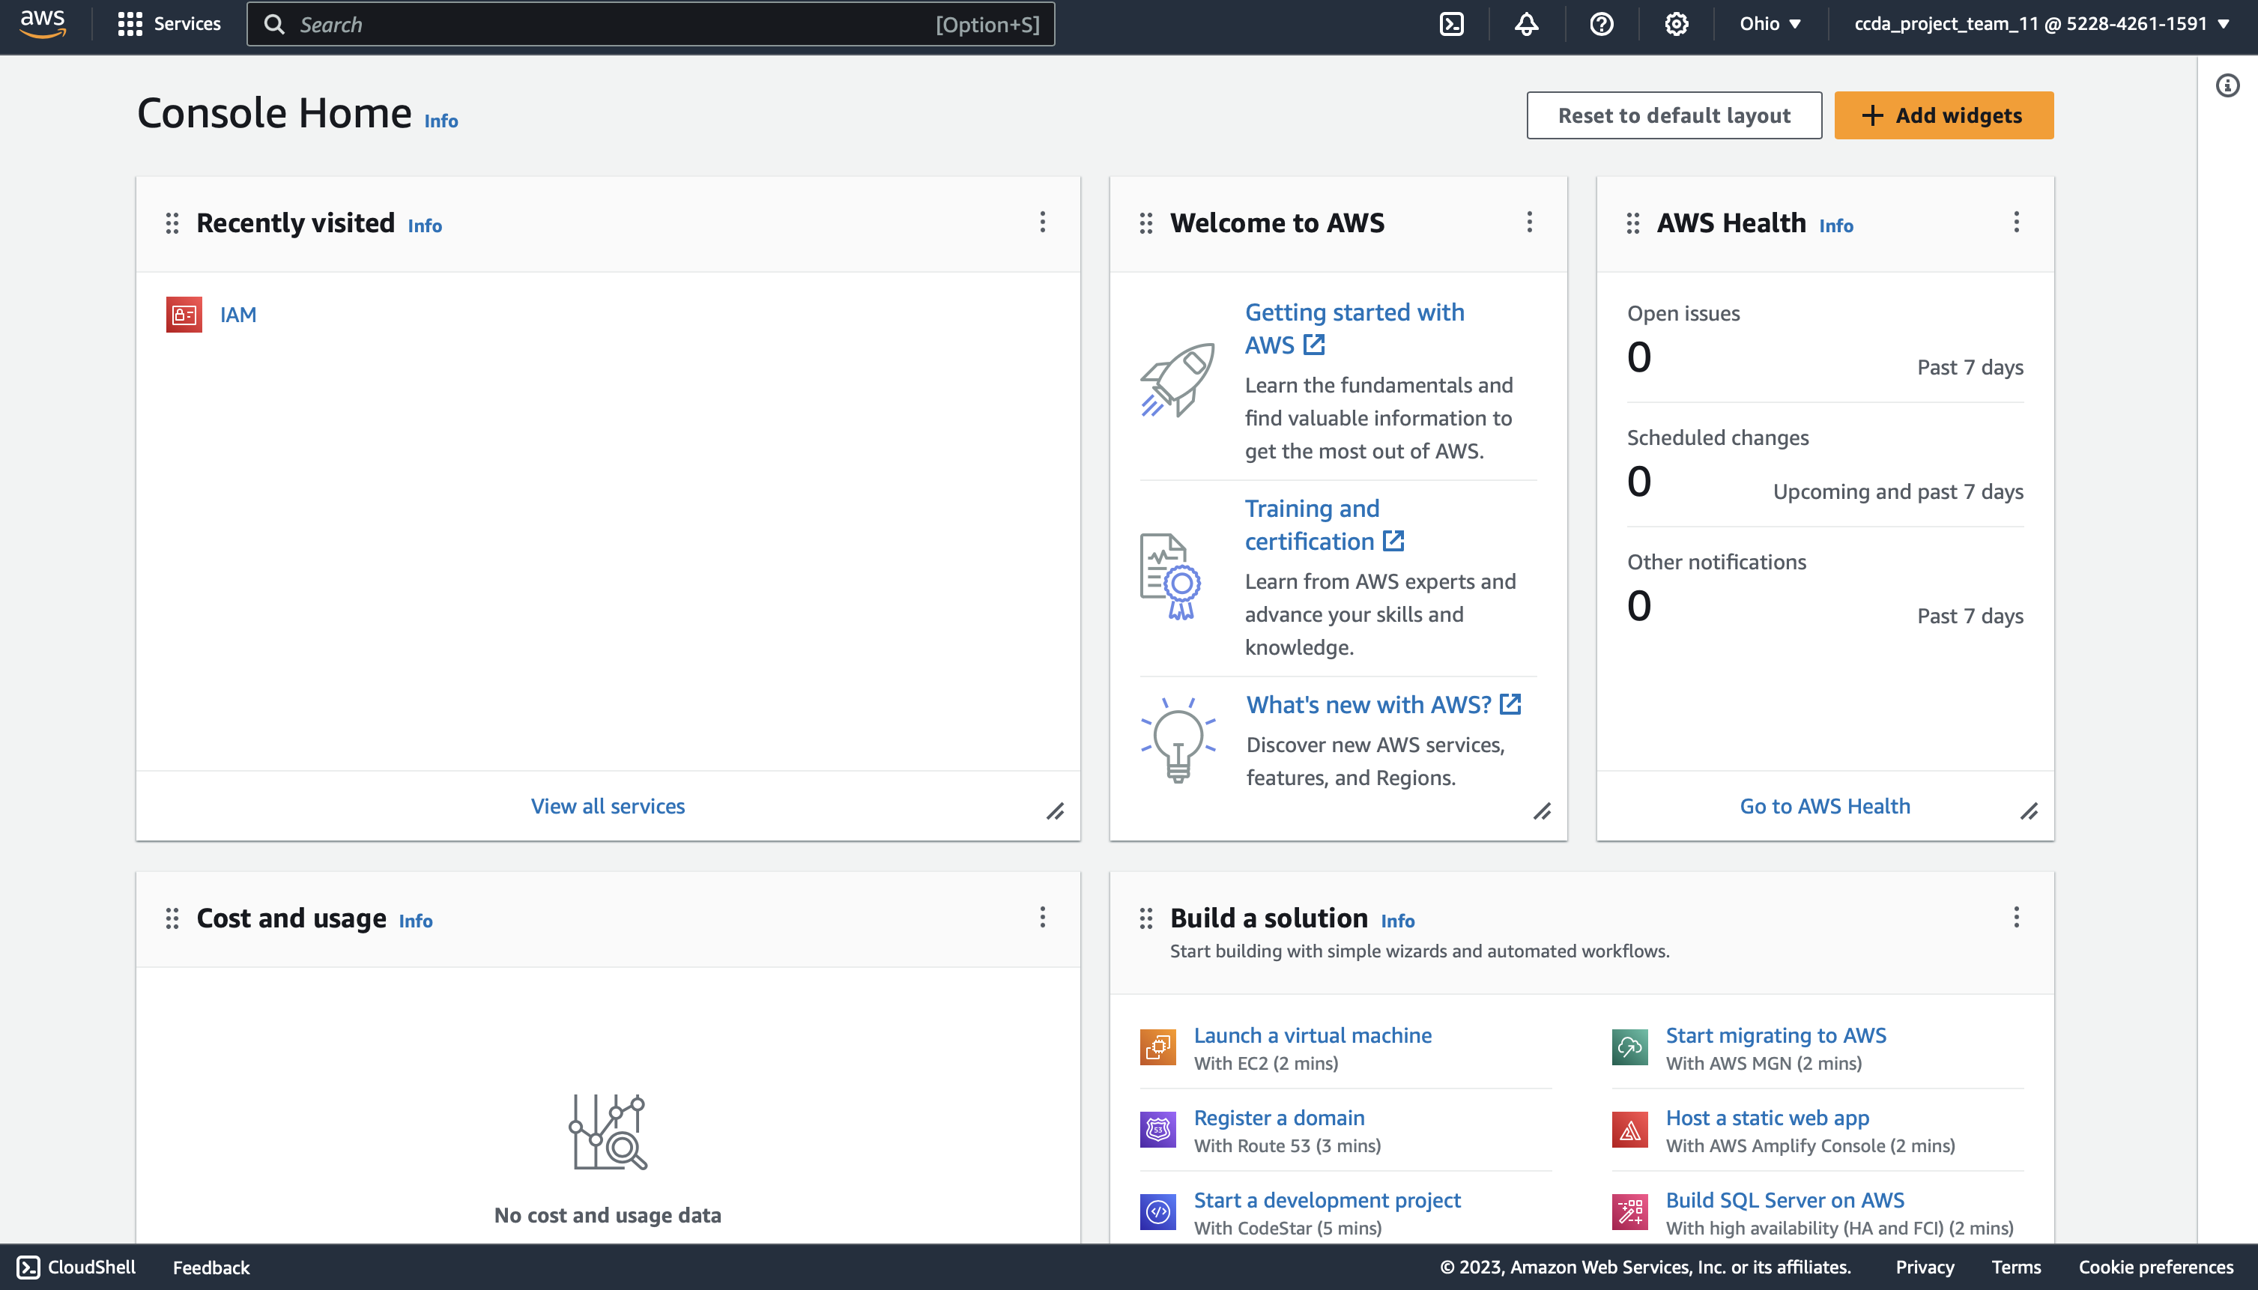

**DATASET –**

For dataset, we are using Google’s open images dataset, setting the type to detection and based on our scope of the project, we are searching for prelabeled plastic bag images.

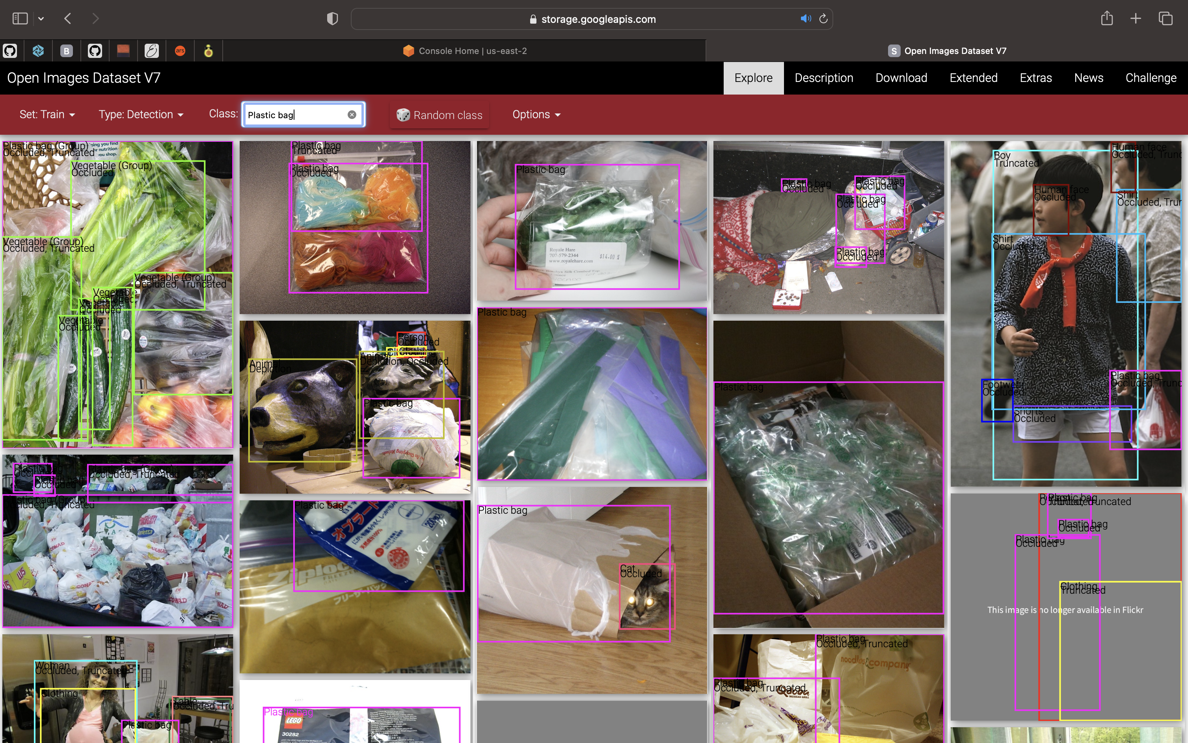

We have utilized fiftyone to download the dataset –

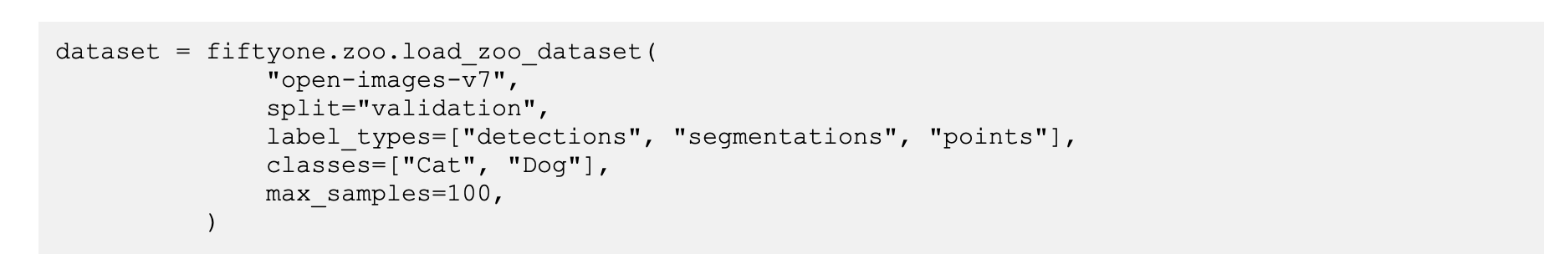

Python code –

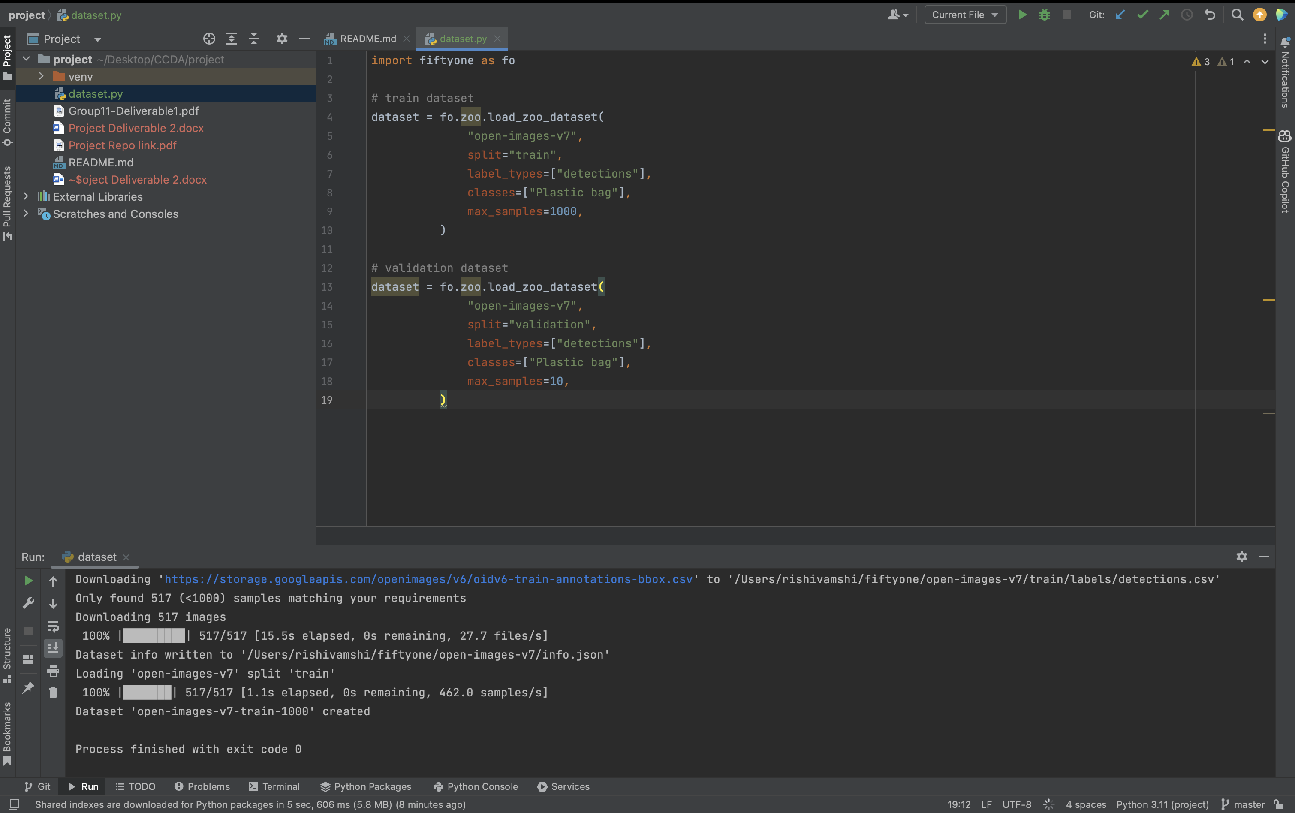

Dataset downloaded –

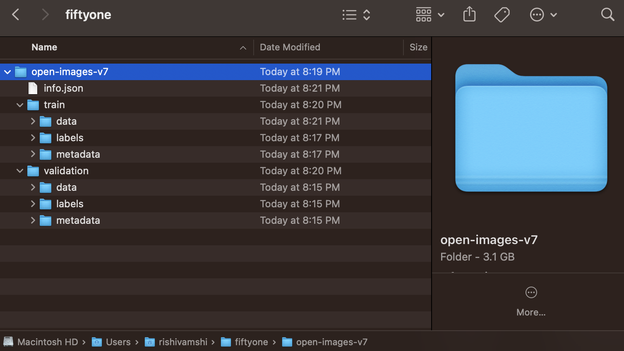

Sagemaker –

Created domain for the project and user –

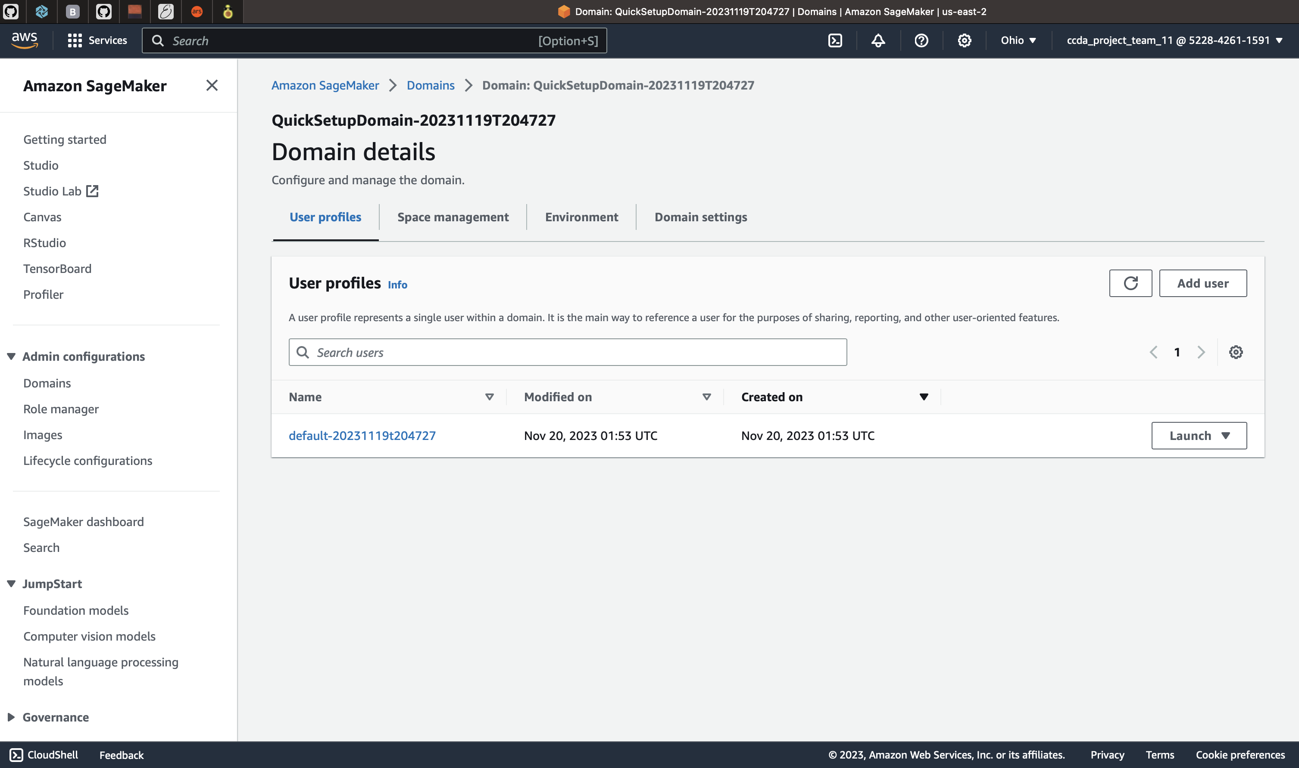

SageMaker Data Science notebook

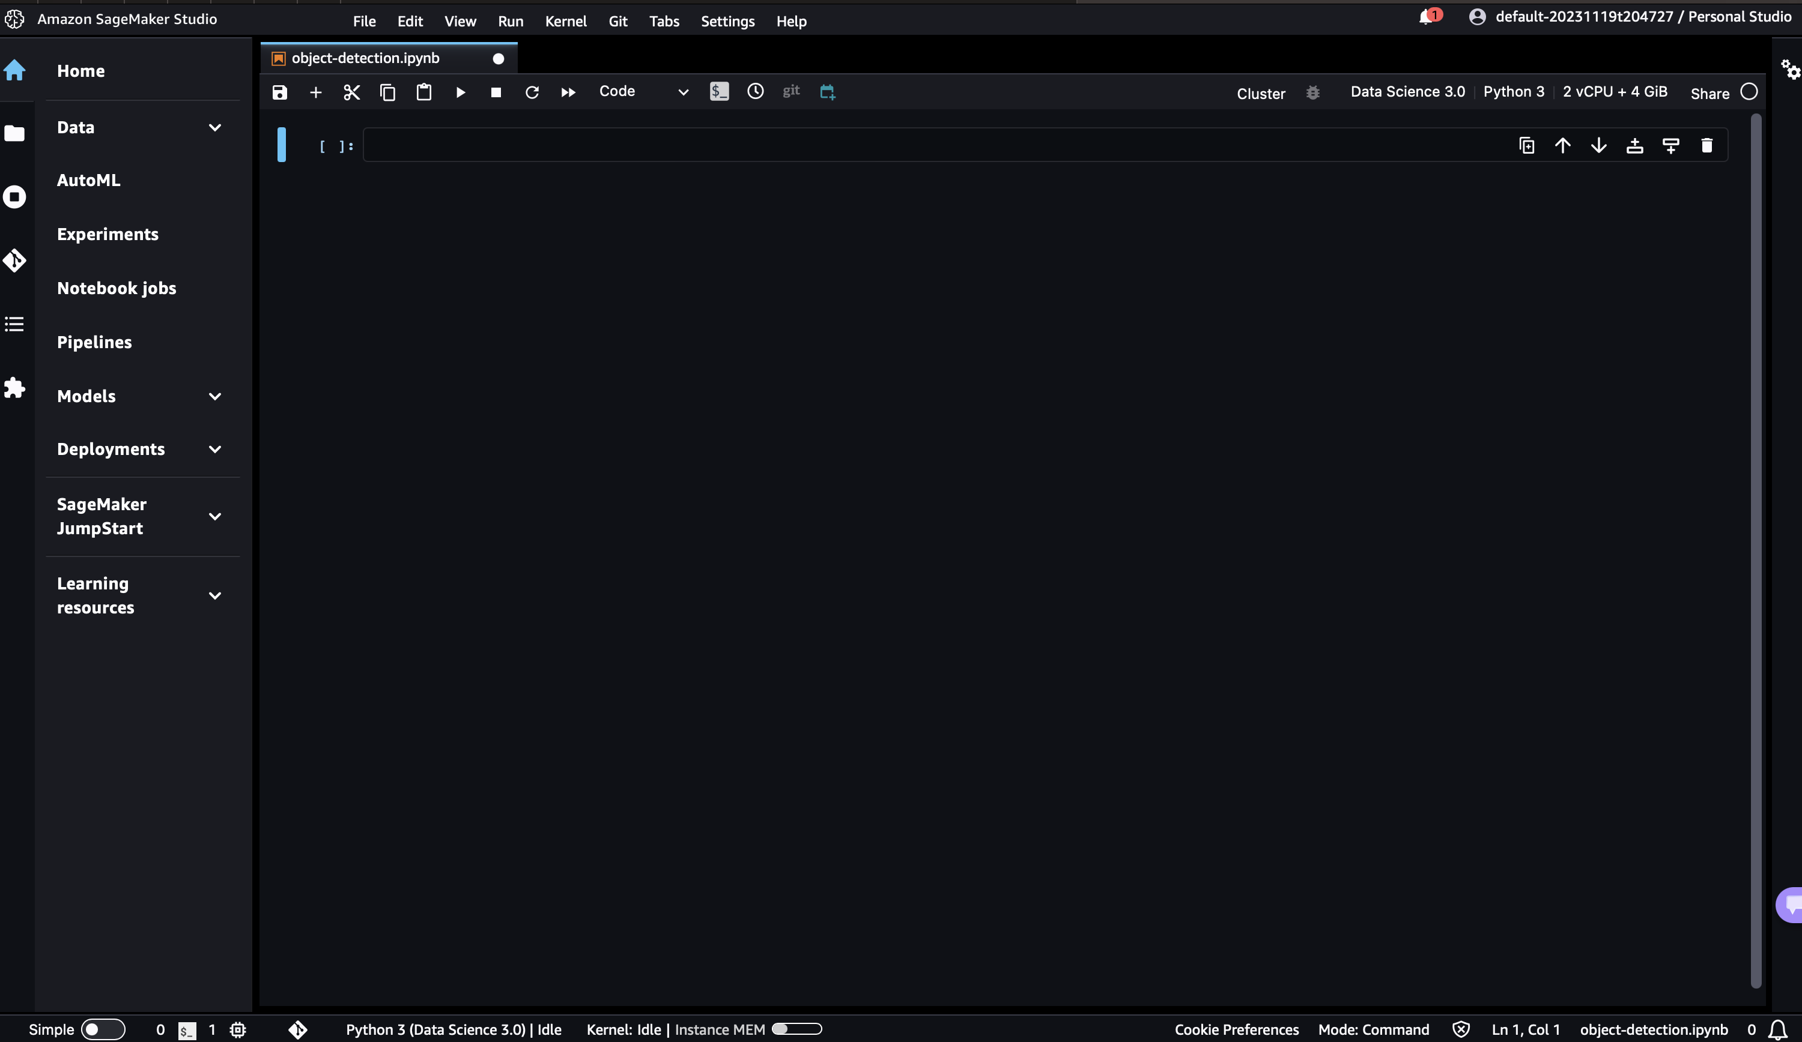

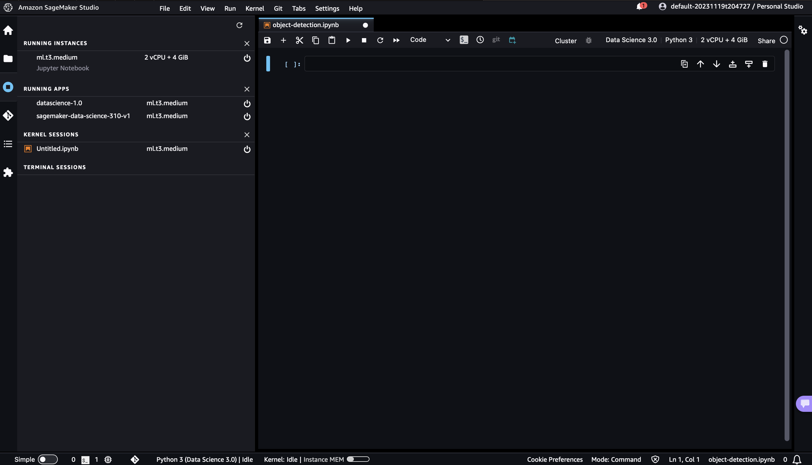

Uploading data to AWS EFS –

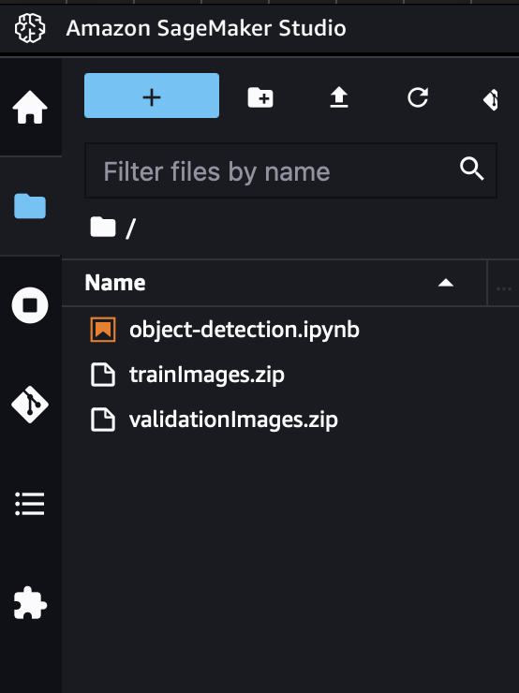

Unzipping the datasets -

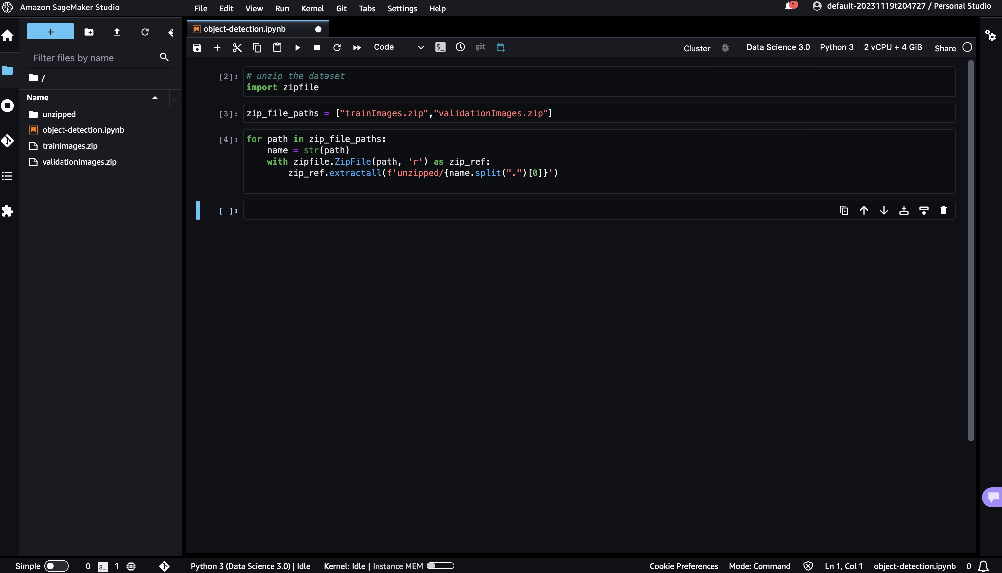

# Performing Explorative Data Analysis =

Switching instance type to ml.t3.2xlarge - this is to process the large datasets

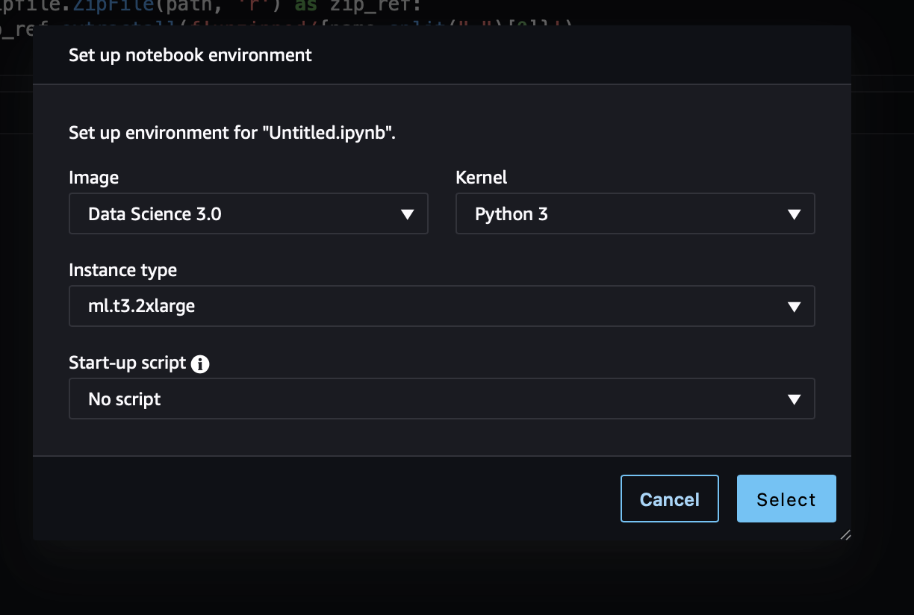

Loading the csv files and understanding the data -   
  
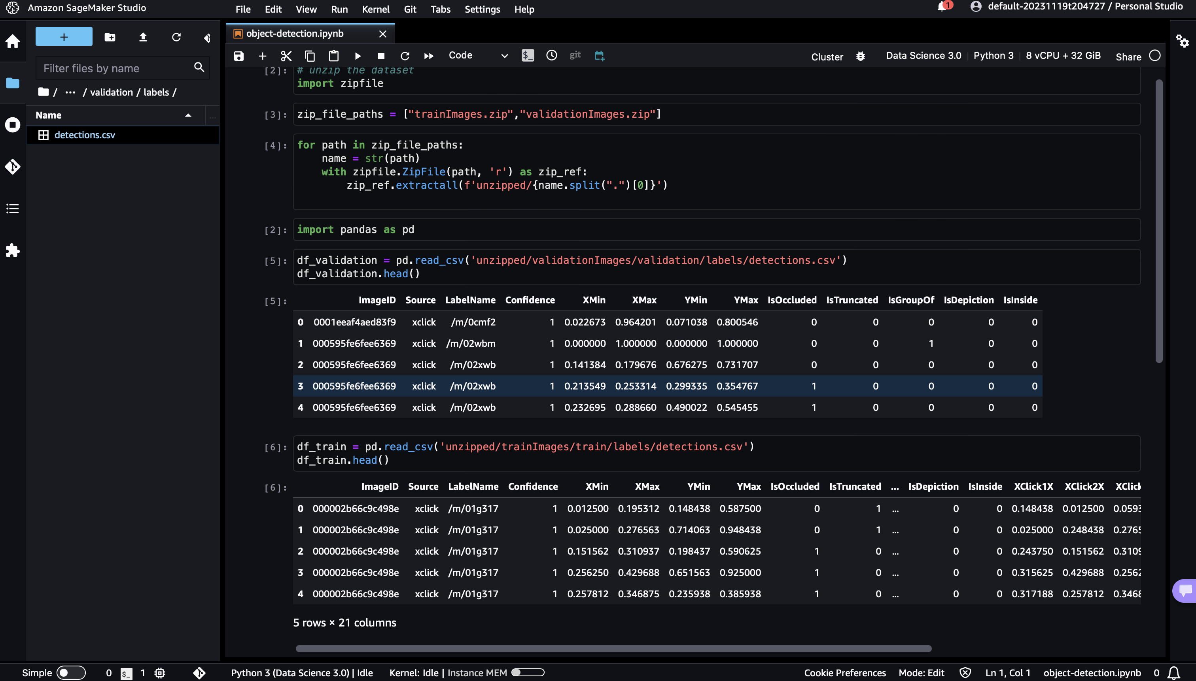

Counting total images and extracting image ids to truncate the excel removing unnecessary rows –

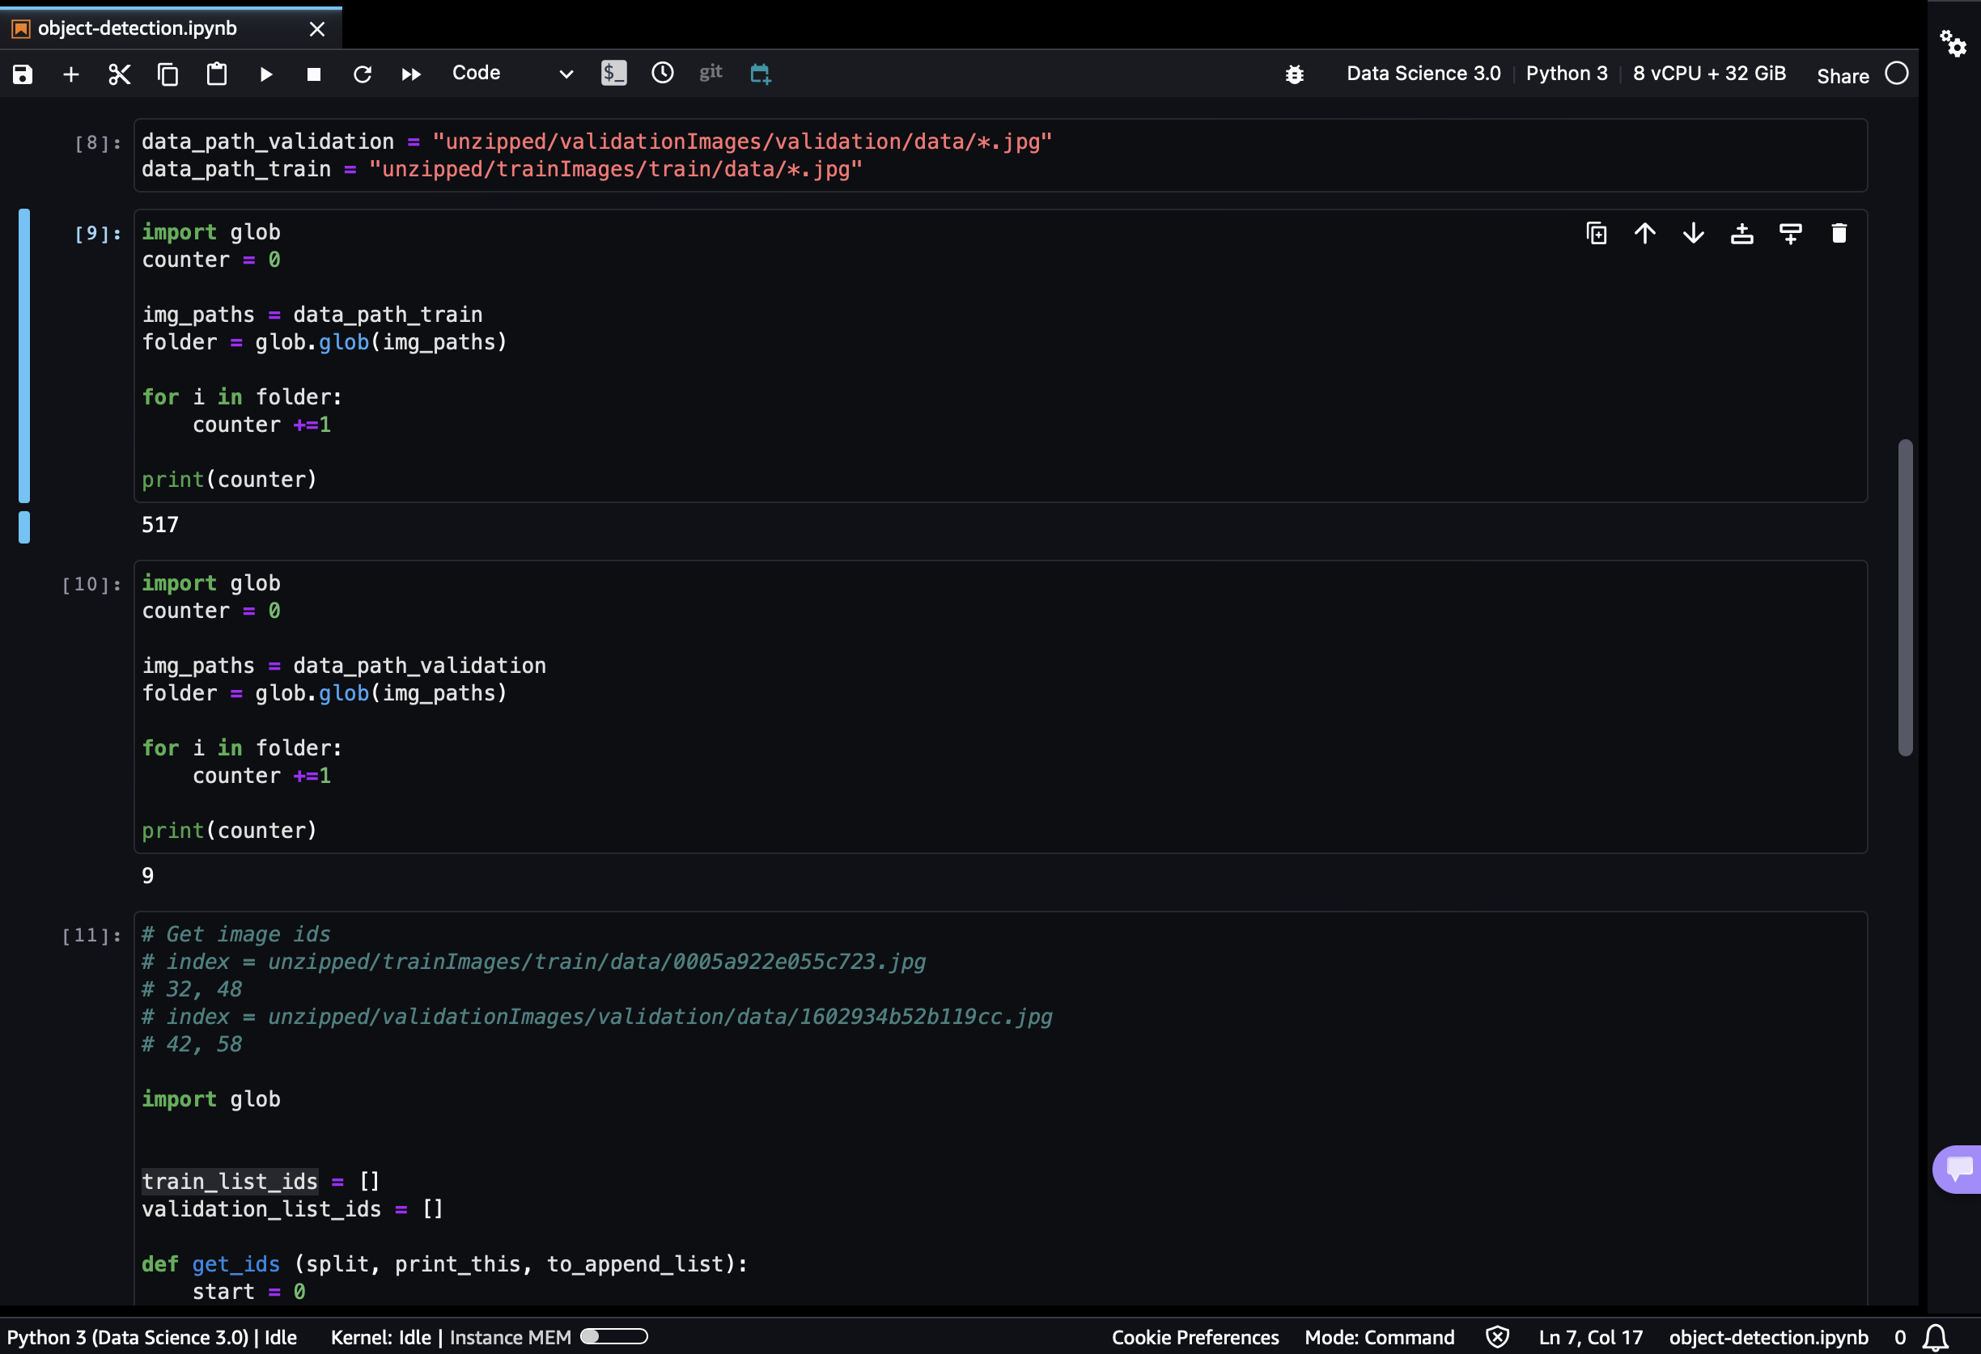

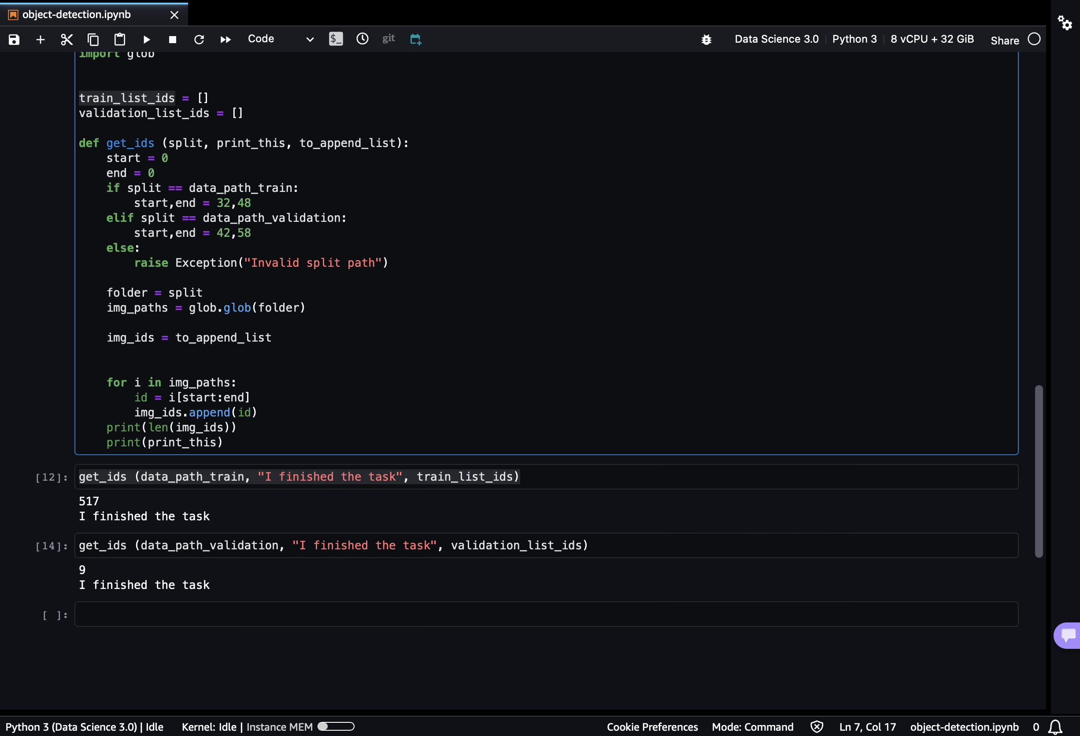

Extracting Class name identifier =

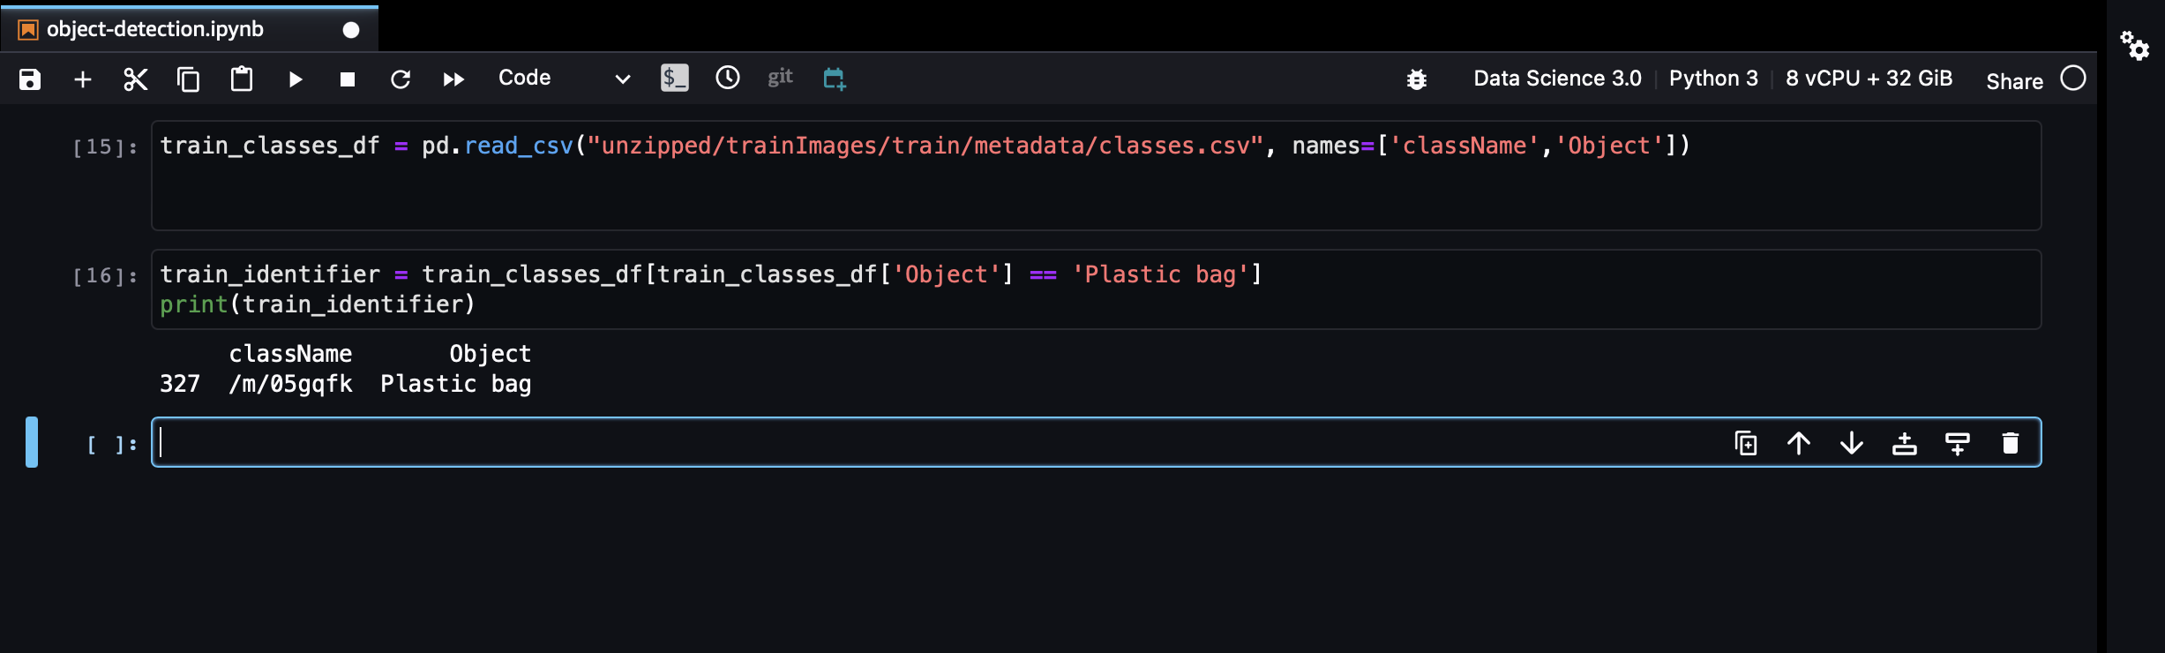

Looking at random samples from the dataframe -

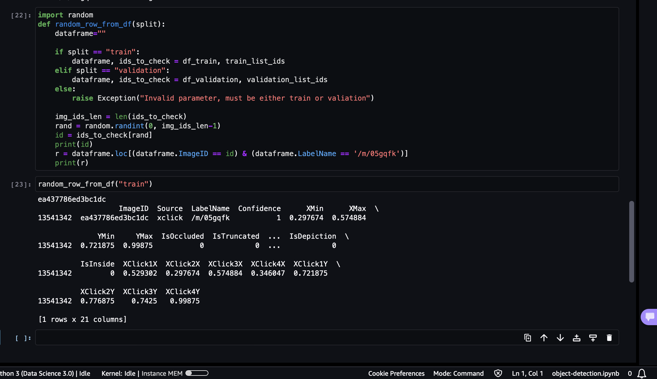

Visualizing Random Images –

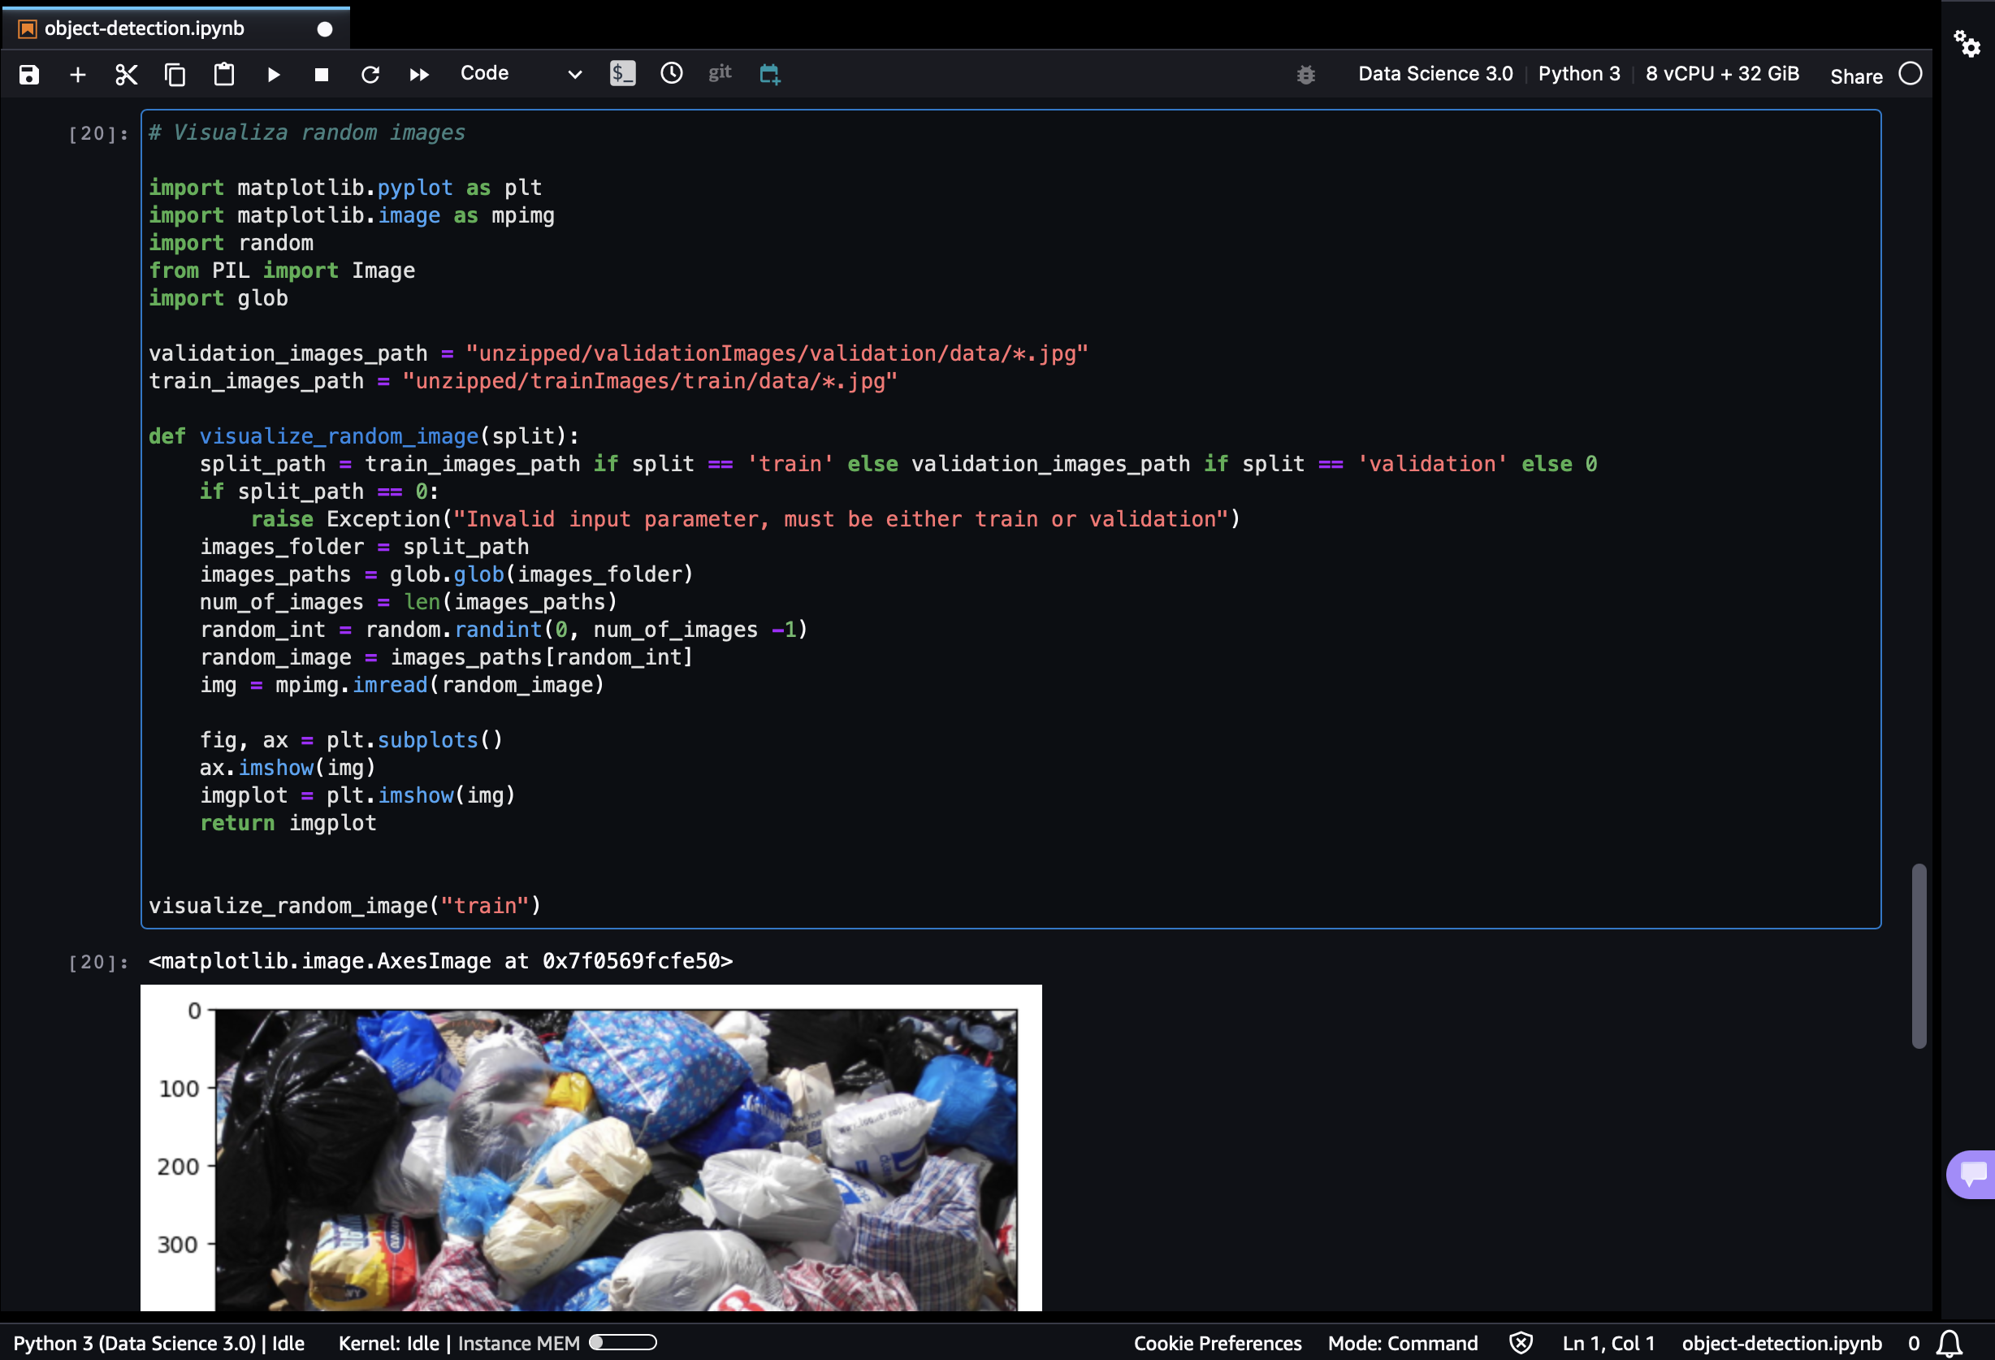

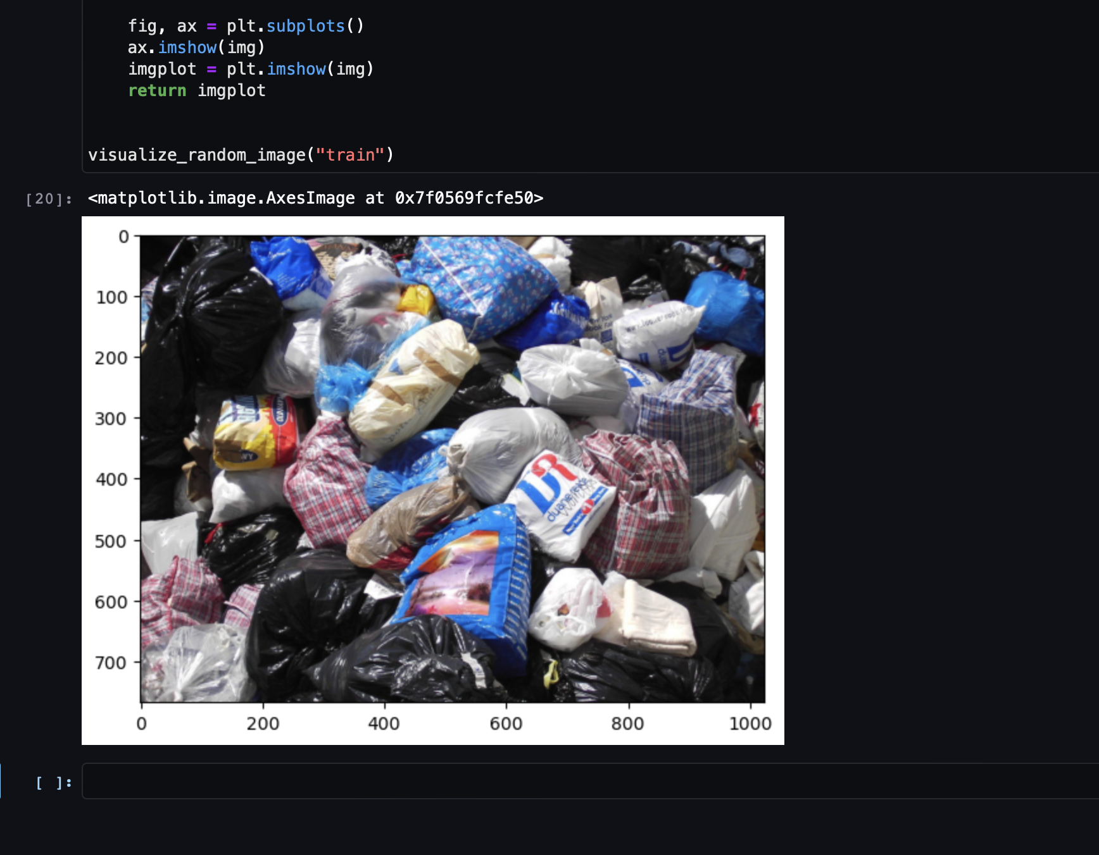

Visualizing images in a grid –

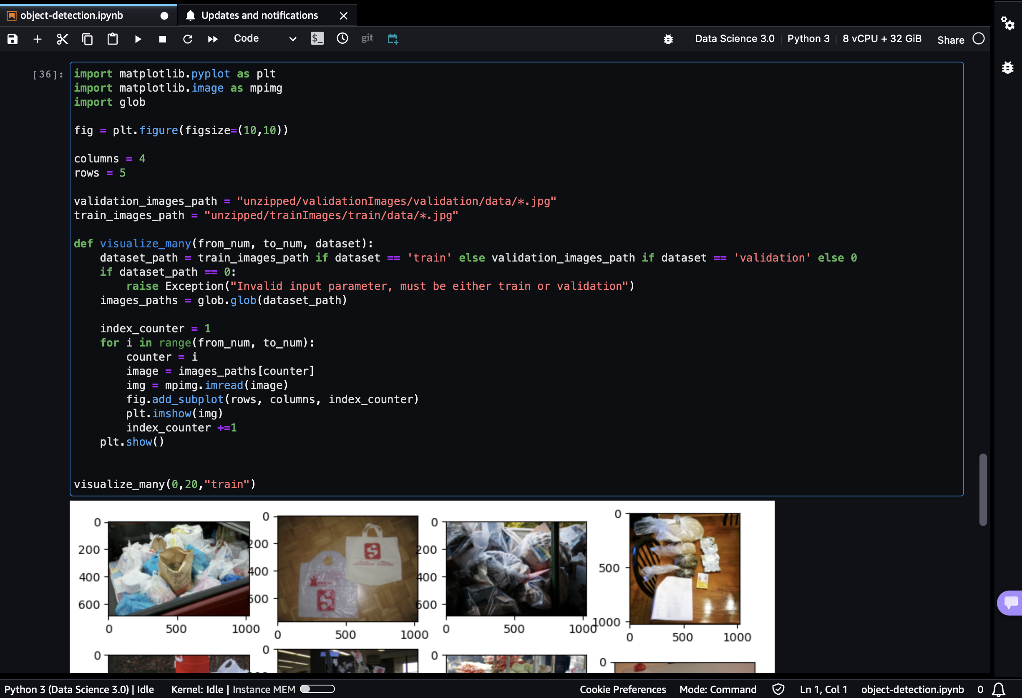

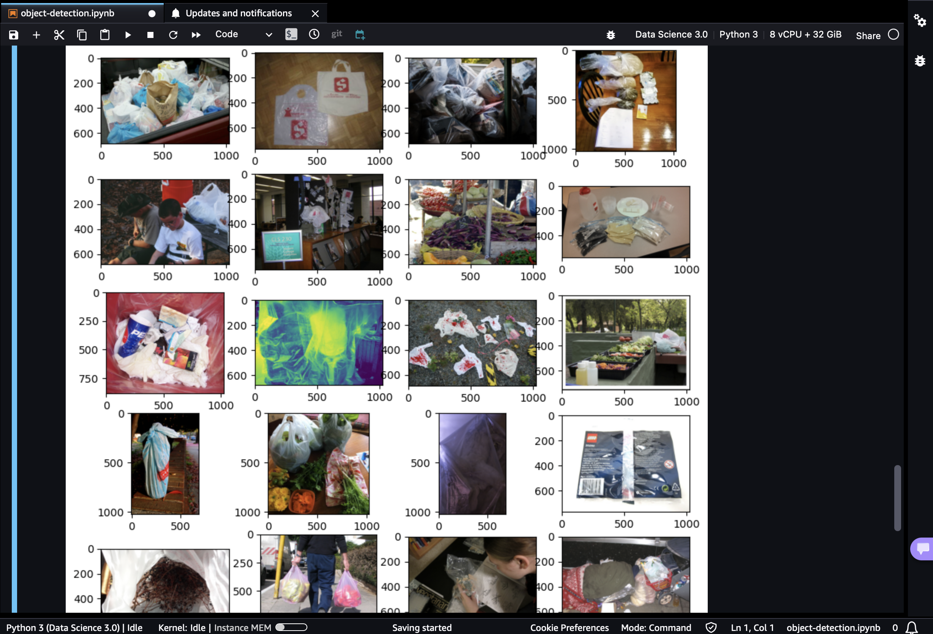

**Building Bounding boxes from the excel sheet onto the images –**

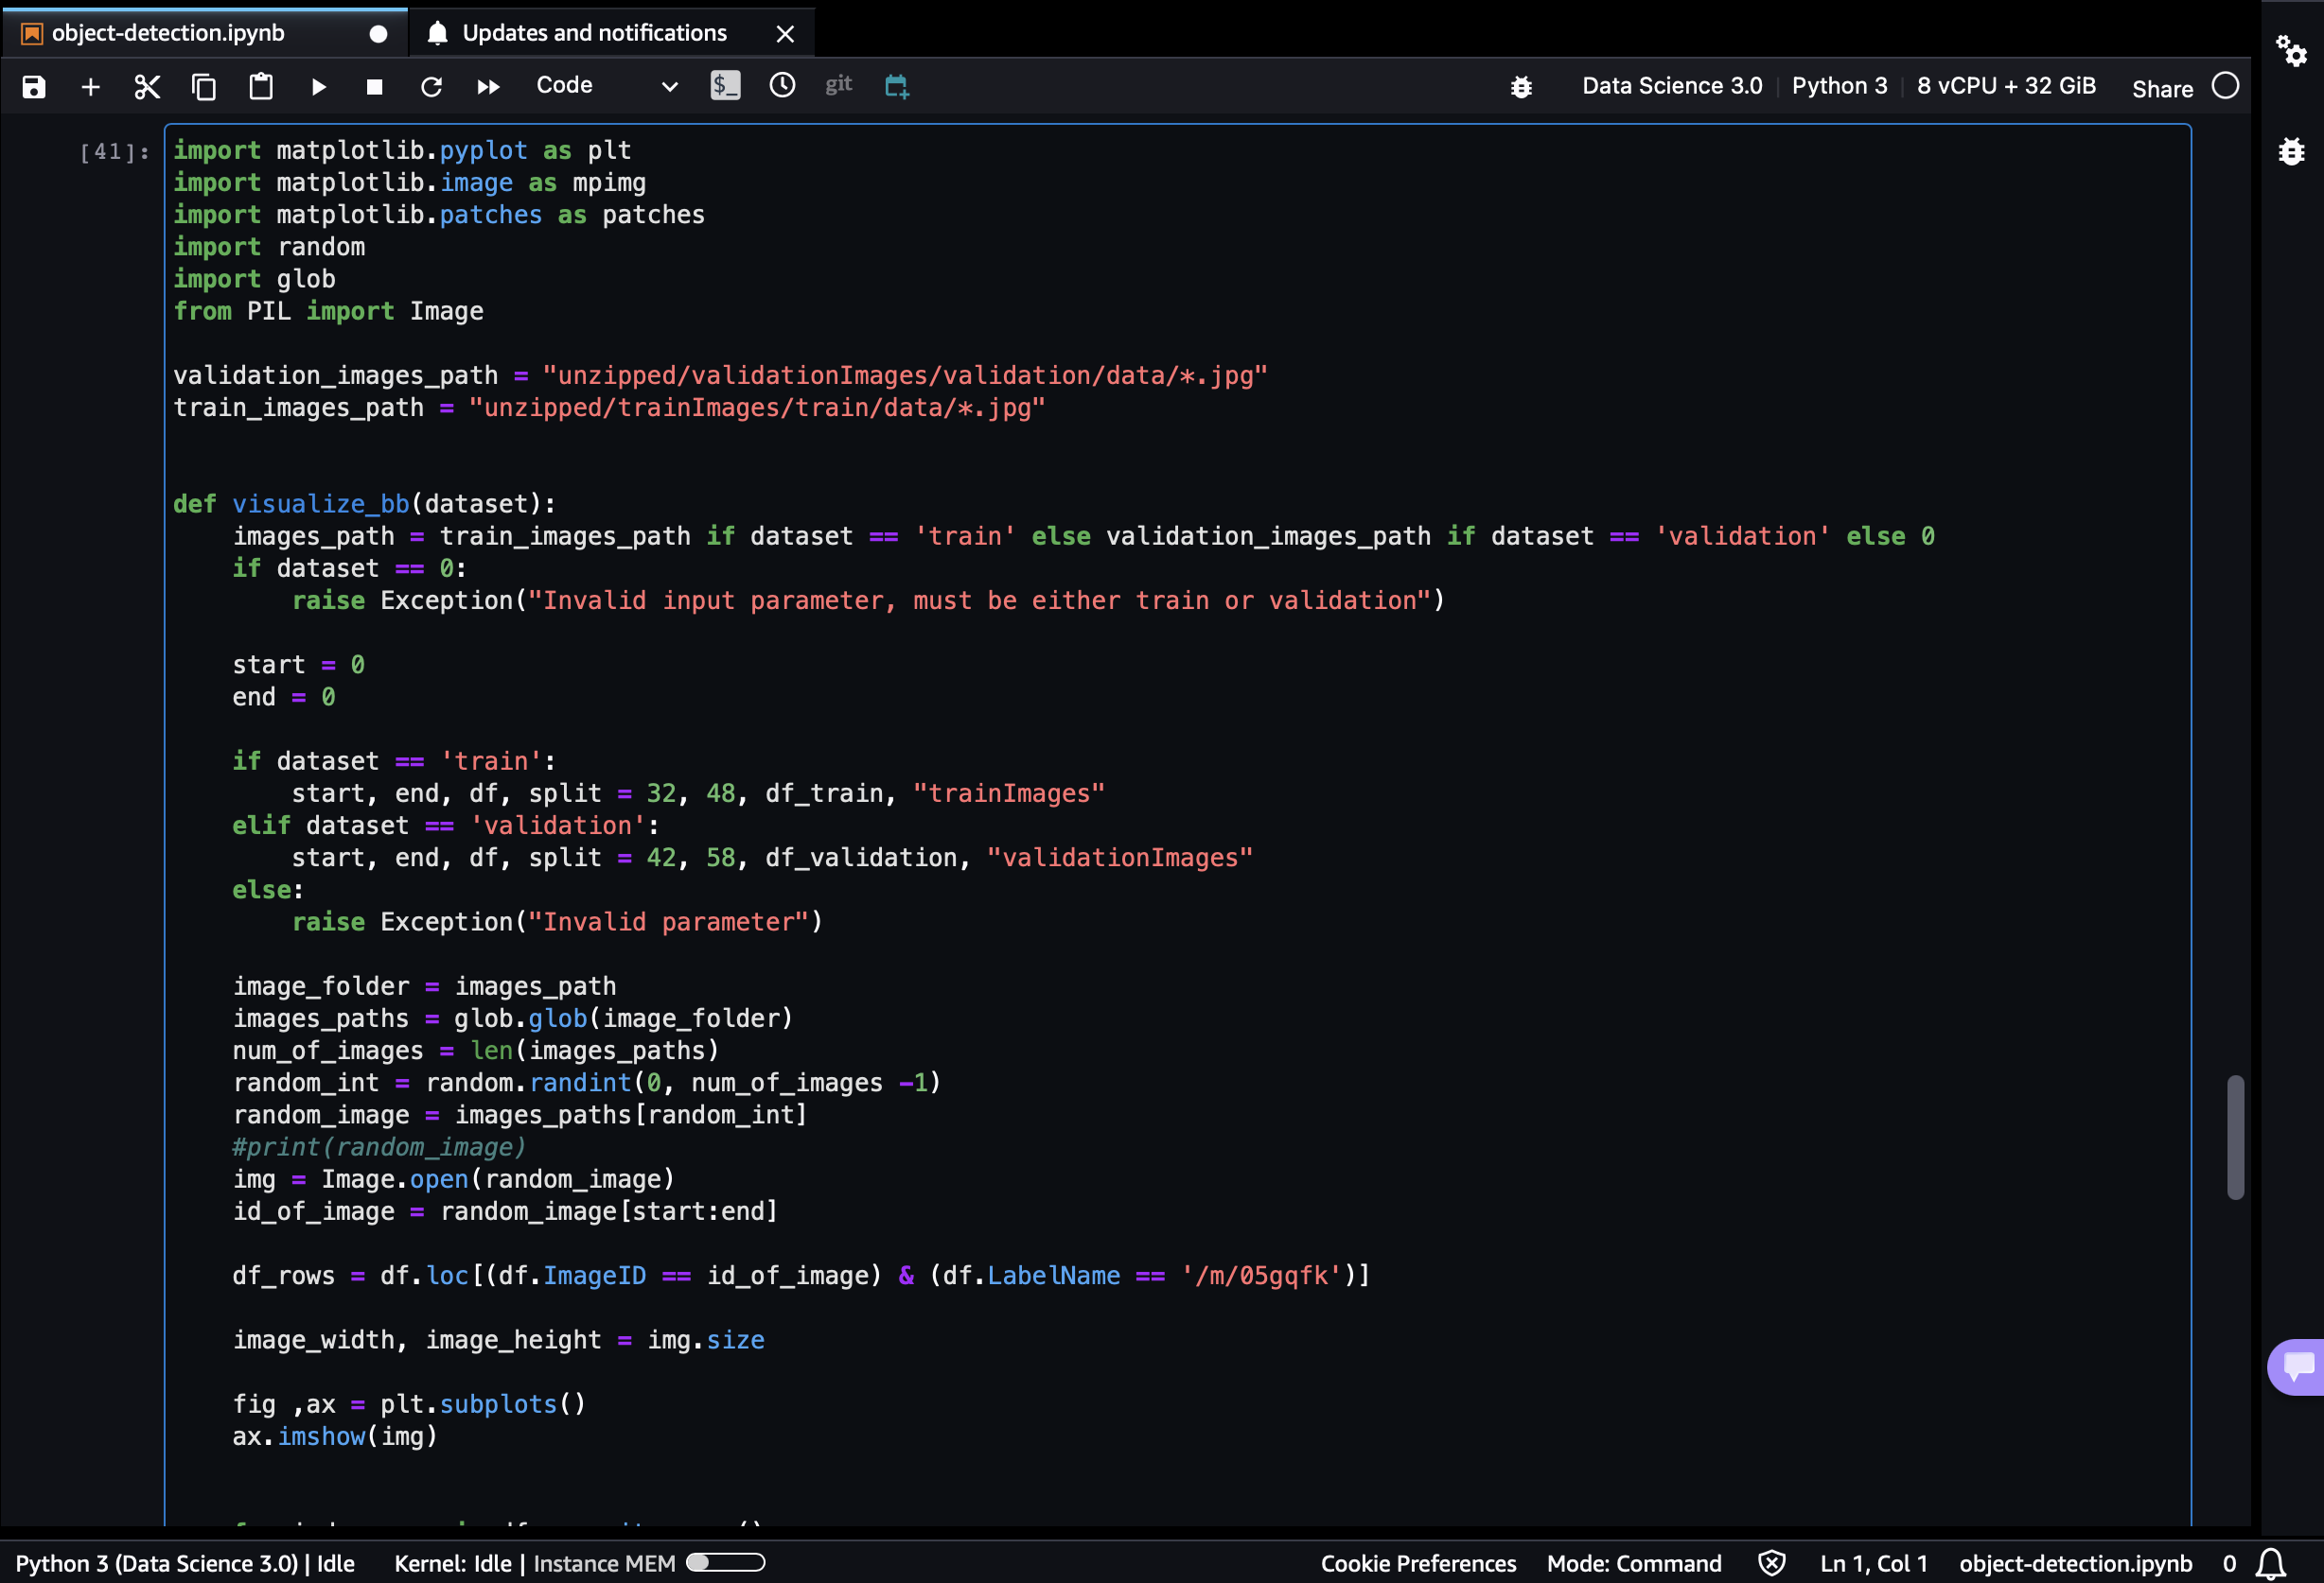

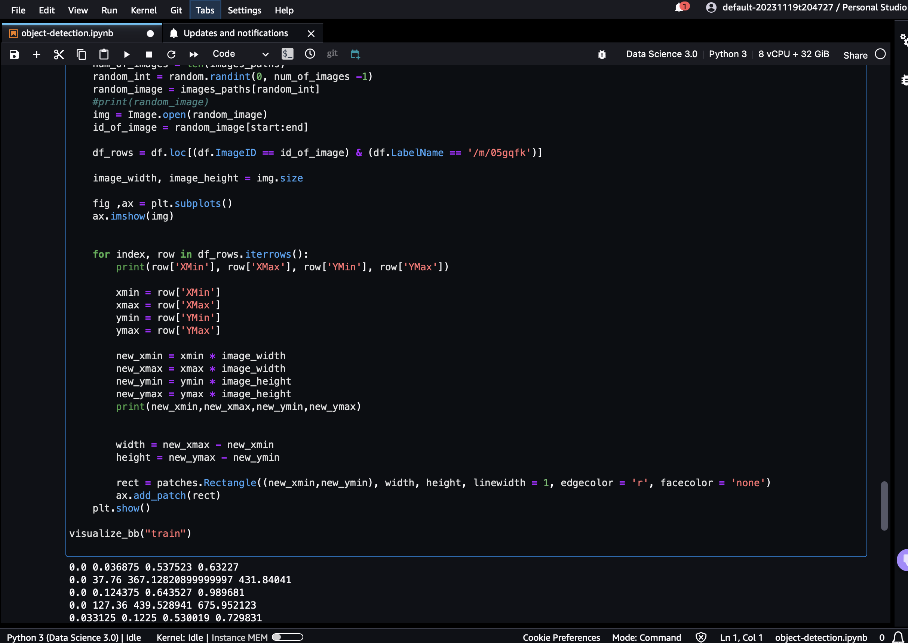

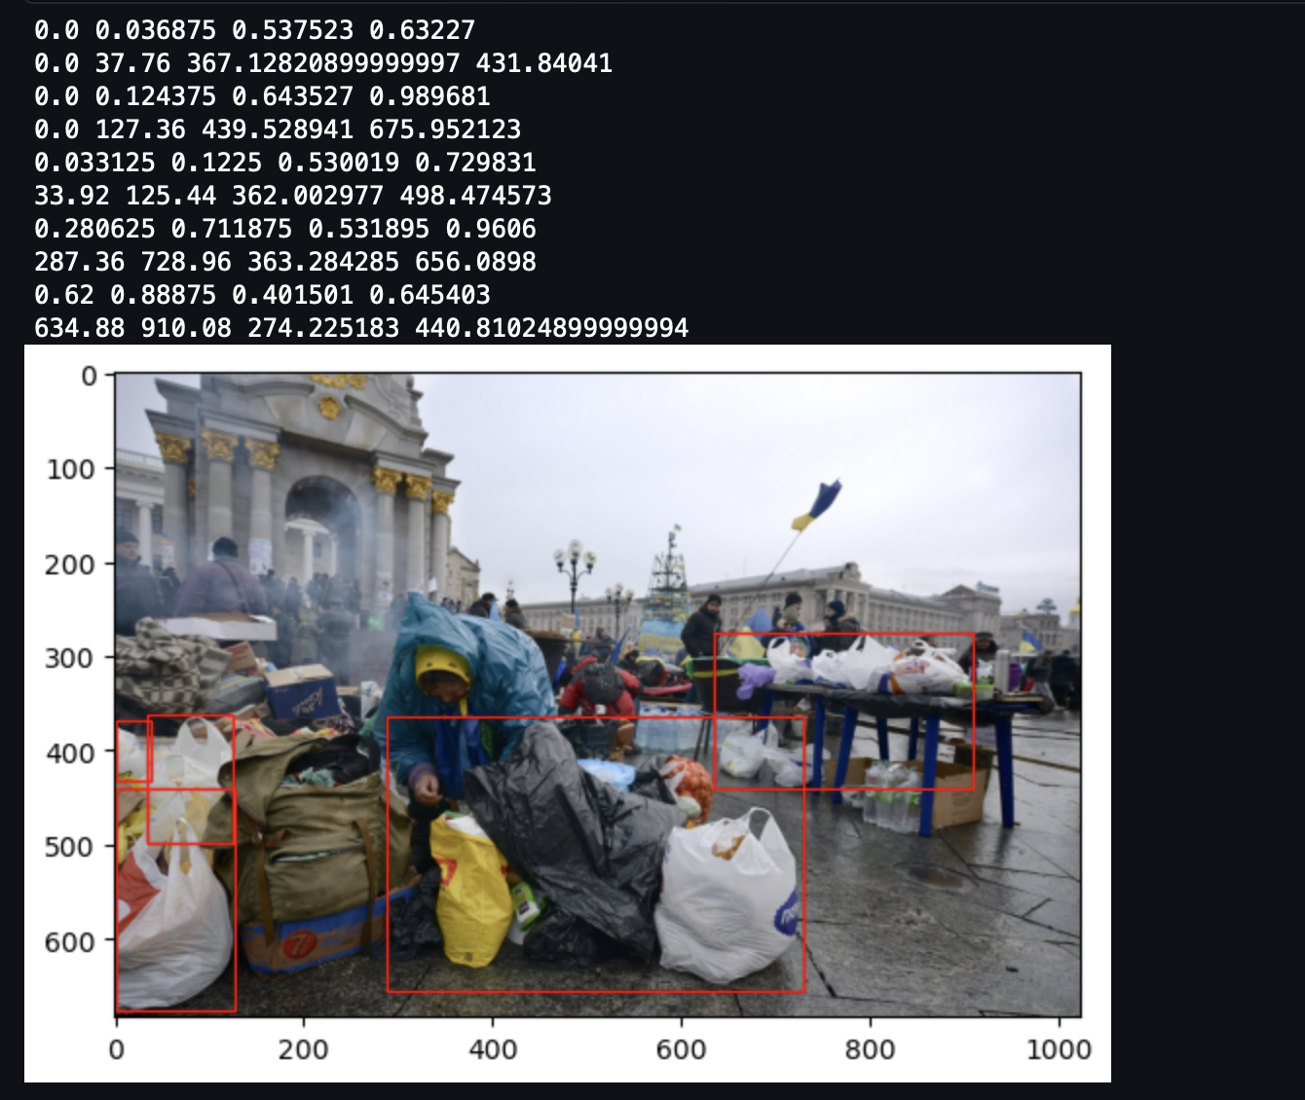

Cleaning the Train and Validation Dataframes and splitting into train and test dataframes –

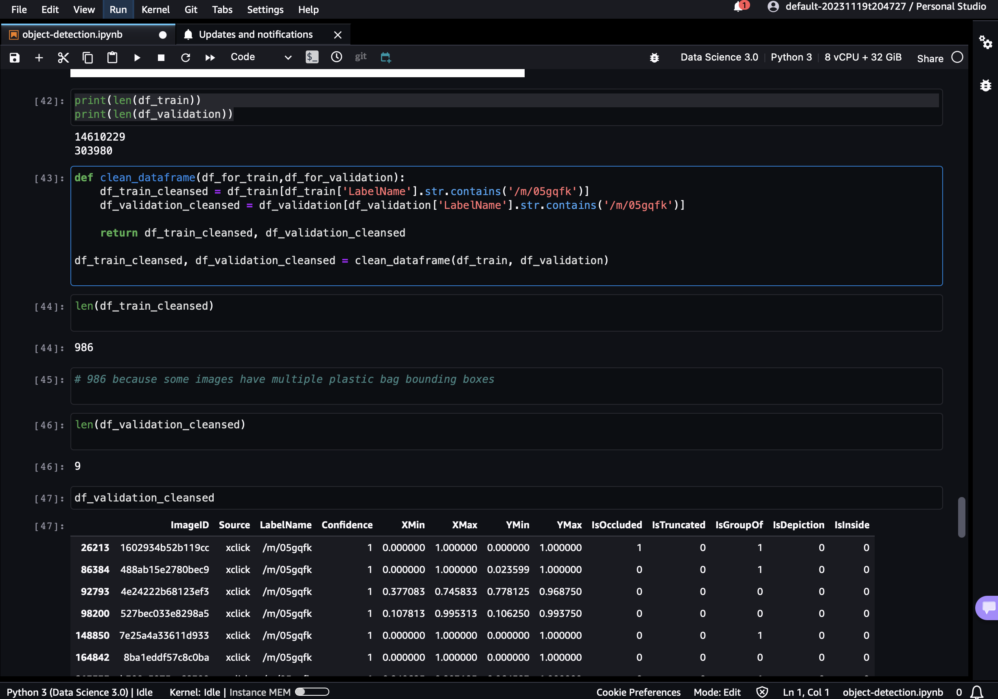

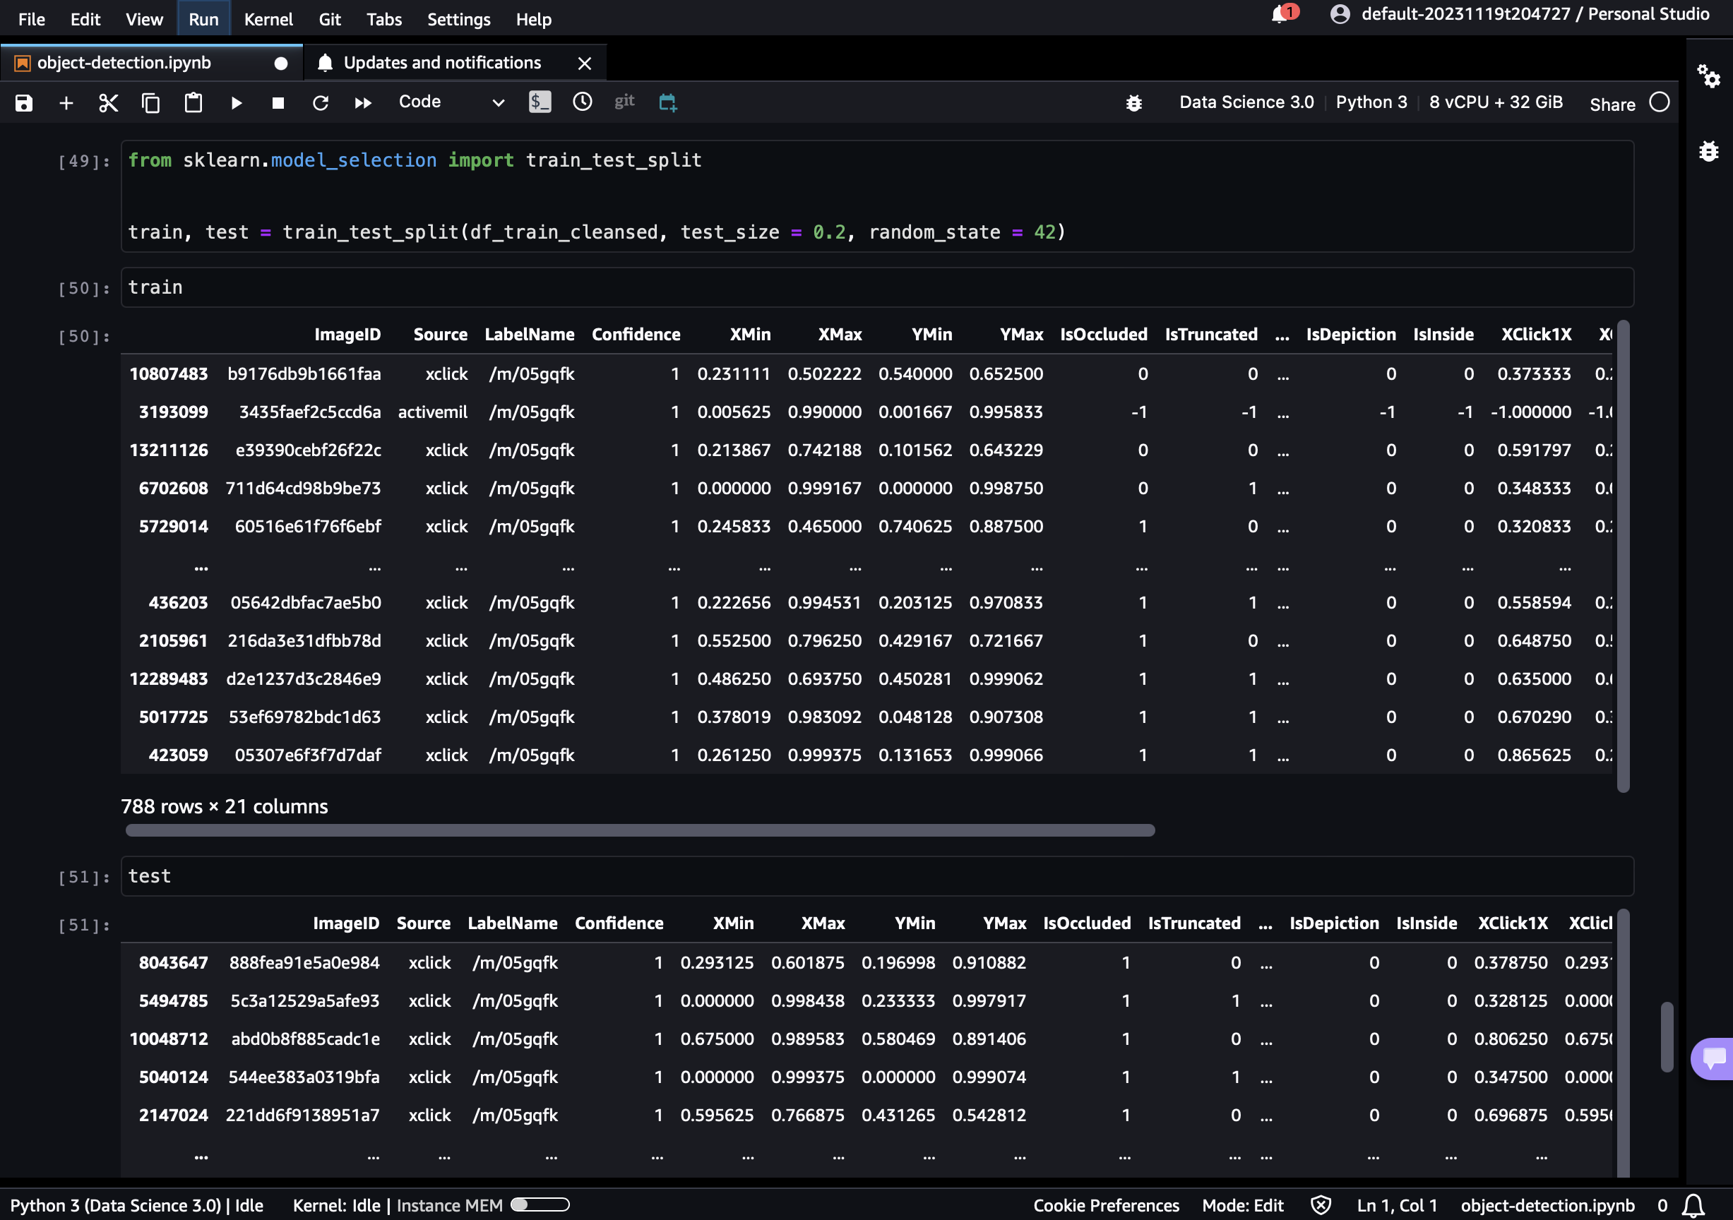

Moving data to testImages folder -

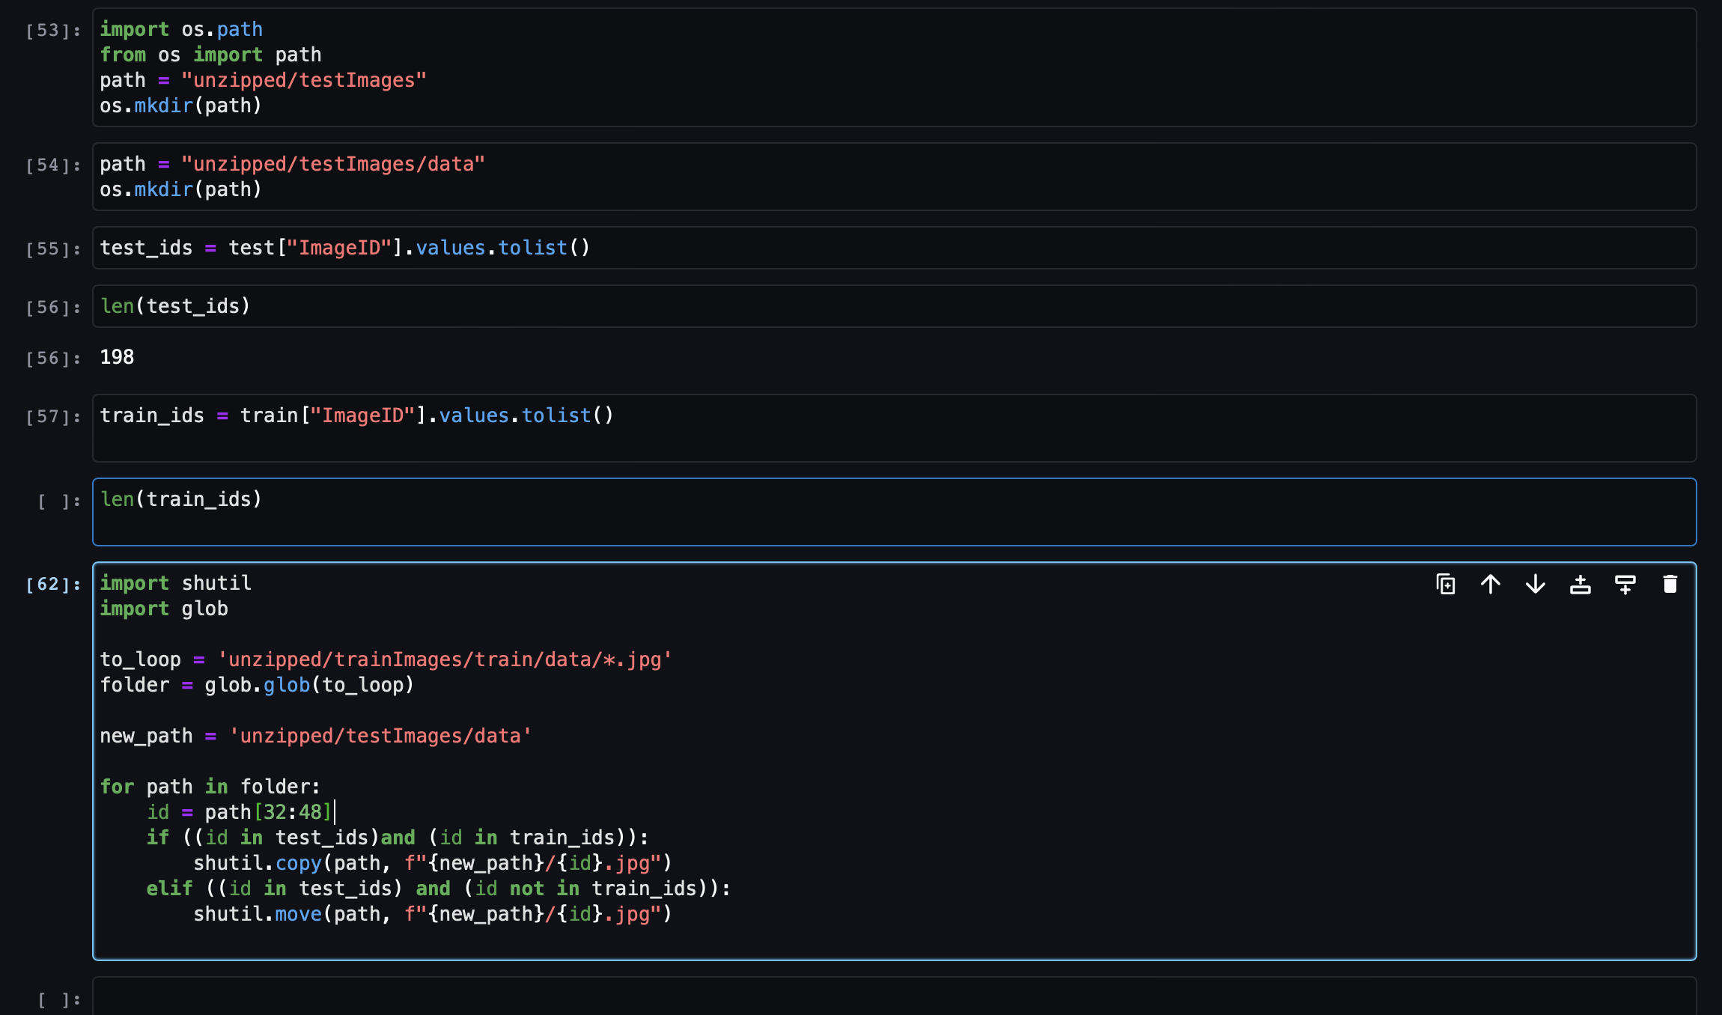

Data Engineering -